15-05-2025
To,
Ms.Amani Madarasinghe
Human Resources Manager,
VIVANTA COLOMBO AIRPORT GARDEN,
No 234 - 236,
Colombo-Negombo Road,
Seeduwa – 11410.
Sri Lanka.
Dear Sir,
Request for Leave to Facilitate Visa Arrangements.
I am writing to formally request leave on behalf of Mr.T.D.P.FERNANDO (Passport No:
N 6724867) for the purpose of facilitating him travel arrangements to Malaysia from 24th June to 30th June as part of a group study program with our partner, the Commonwealth Youth Network.

The leave is required to complete the visa application process. To ensure these preparations are completed on time, him leave approval letter must be urgently collected and submitted.
We kindly request your approval of this leave request to enable him to meet the necessary deadlines for him travel. Your prompt attention to this matter will be greatly appreciated.
Thank you for your understanding and support.

For further enquiries please contact our focal point for Sri Lanka:
Mr. Gayan Rajapaksha, Chairperson, Commonwealth Youth Network of Sri Lanka.
+94777138134, gayanraj@outlook.com
Mr. Goyum Prabath Rupasena, Secretary, Commonwealth Youth Network of Sri Lanka. +94718081831, goyum85@gmail.com
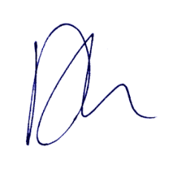
With high regards,

DHANESH BASIL,
National President,
Malaysian Indian Youth Council (MIYC),
Malaysia.

